AFF - NFB Affiliates Website Training Manual
- 1. Introduction
- 2. Backend Drupal Access
- 3. Content Management
  - 3.1 Basic Page
  - 3.2 Blog
  - 3.3 Board of Directors
  - 3.4 Chapter Details
  - 3.5 Chapters Page
  - 3.6 Event
  - 3.7 Gallery
  - 3.8 Inner Page
  - 3.9 News
  - 3.10 Programs
  - 3.11 Web forms
  - 4. National Featured Content
  - 4.1. National Featured Content - Front End
  - 4.2. National Featured Content - Back End
  - 4. CiviCRM Sync

1. Introduction
The purpose of this document is to provide necessary guidance for the Administrator/Content Editor to make necessary changes to various content of the website through the backend drupal application.

2. Backend Drupal Access
To access the backend drupal application of the website user need to login into website using backend URL.
URL format of backend : “website URL”/user/login. For example, for North Dakota it would be: https://www.nfbnd.org/user/login
Login screen of Backend : The screen where user need to input username / password in order to access backend drupal application.
Design 1
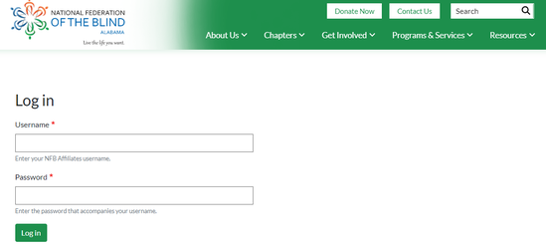
Design 2
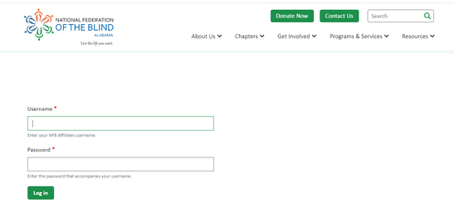

3. Content Management
URL for Content addition will of the format : “website URL”/node/add.
There is an alternate way to access this content addition screen which is explained as following:
- Once user logs in to drupal backend, click on “Manage” menu (first menu in the top bar).
- This will open up a tool bar, click “Content” from this tool bar.
- The resulting page will have a button saying “Add content”.
- Click on “Add content” to lead to content addition.
Various content types available are:

3.1 Basic Page
Basic page content type is used to create pages such as Homepage, Landing Page etc. The pages with dynamic data can be managed with this content type. Fields under Basic Page content types are:
Table 1 Basic Page Content Type with Field Names and Detalis
# | Field | Description
1 | Page Banner | The banner for the page needs to be upload for that specific page.
2 | Page Summary | The summary about the page needs to be added here. Fields ‘a' and 'b’ will be rendered as this layout.
3 | Dynamic Data Block | All the dynamic data will be rendered through this field. Below is the section from the template site being rendered using this field.  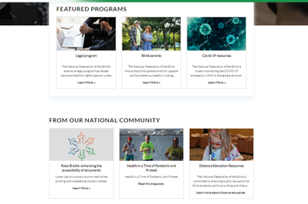
4 | Single Column Content | This field will display the section of the page which is rendered using single column layout. Taking the consideration of template site below is the relevant section.
5 | Content Area | This field will be used to display the four column layout as seen below, the author will require to choose “AFF Landing Page Four Column Layout” field type four times to get the layout as seen below.  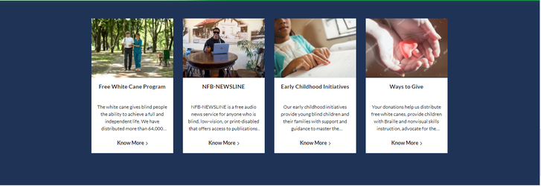

3.2 Blog
This content type is used for Blog landing pages. Fields under Blog content types are:
Table 2 Blog Content Type with Field and Description
# | Field | Description
1 | Title | The title of the blog needs to be added.
2 | Body | The body of the blog needs to be added here.
3 | CTA Label | The label for the CTA button needs to be displayed, if left blank will display as “Read” when the blog is referenced.
4 | CTA Link | The link can be external or internal on which needs redirection when user clicks on the blog, if left blank respective page will be redirected.
5 | Blog Category | The category of the blog can be choose from this field can be single or multiple.
6 | Blog Image | The thumbnail image to be displayed when the blog is referenced.
7 | Blog Page Banner | The banner image for the blog.
8 | Blog Publish Date | The publish date for the blog.

3.3 Board of Directors
This content type is used for adding details about the board members of each affiliate. Fields under Board of Directors content types are:
# | Field | Description
1 | Title | The name of the board member to be added here.
2 | Picture | The picture of the board member.
3 | Designation | The designation of the board member.
4 | Email | The email of the board member.
5 | Member Designation | The field to display to if member is member of the board or director.

3.4 Chapter Details
This content type is used to add details about each chapter. Fields under Chapter Details content types are:
# | Field | Description
1 | Title | The title of the chapter to be added here.
2 | Body | The general information about the chapter to be added here.
3 | Meetings | The information about the meetings to be added here.
4 | Additional Notes | The additional note administrator want to display for that specific chapter.
5 | Chapter Contact Person | The contact person name from the chapter.
6 | Chapter Person Email | The email of the contact person.
7 | Chapter Contact Person Phone | The contact no of the chapter person, home, ext will need to be added using below method :  Separate phone type by pipe (|) sign i.e. 123-456-789|home  Add ext. by mentioning using 123-456-789|ext.123
8 | CTA Label | The label for the CTA button needs to be displayed, if left blank will display as “Read” when the chapter is referenced.
9 | CTA Link | The link can be external or internal on which needs redirection when user clicks on the chapter, if left blank no redirection will happen.

3.5 Chapters Page
This content type is used to display landing page for the chapters. Fields under Chapters Page content types are:
# | Field | Description
1 | Title | The title of the chapters landing page to be added here.
2 | Body | The description of the chapters landing page needs to be added here.
3 | Chapter Page Banner | The banner image for the chapters page.
4 | Chapter Details | The configuration option to display all chapters page in the current landing page if removed none of the chapters added from “Chapters Details” will be displayed.

3.6 Event
This content type is used to add details about single event that is scheduled for the future or scheduled in the past. Fields under Event content types are:
# | Field | Description
1 | Title | The title of the event to be added here.
2 | Body | The general information about the chapter i.e. event info, address to be added here.
3 | Event Contact Person | The name of the contact person if applicable need to add here.
4 | Event Contact Person Email | The email of the contact person if applicable need to add here.
5 | Event Contact Person Phone | The phone number of the contact person for the event to be added home, ext will need to be added using below method:  Separate phone type by pipe (|) sign i.e. 123-456-789|home  Add ext. by mentioning using 123-456-789|ext.123
6 | CTA Label | The label for the CTA button needs to be displayed, if left blank will display as “Read More” when the event is referenced.
7 | CTA Link | The link can be external or internal on which needs redirection when user clicks on the event, if left blank no redirection will happen.
8 | Event Fee | Event fee if applicable need to be added here.
9 | Event Start Date | The date and time the event will be end, need to mention here.
10 | Event End Date | The date and time the event will be end, need to mention here.

3.7 Gallery
This content type is used to create a image gallery to showcase the images. Fields under Gallery content types are:
# | Field | Description
1 | Title | The name of the gallery.
2 | Body | The description about the gallery.
3 | Gallery Page Banner | The banner image for the gallery landing page.
4 | Gallery Thumbnail | The thumbnail image to be displayed when the gallery is referenced.
5 | Gallery Images | The images to be used in the gallery to display on the carousel.
6 | Image | The actual image to be displayed.
7 | Image Caption | The caption to display when the image is displayed on the full width.

3.8 Inner Page
This content type is used to display inner static pages of the website i.e. About Us. Fields under Inner Page content types are:
# | Field | Description
1 | Title | The name of the gallery.
2 | Inner page Content | The content of the page can be added under this field.
3 | AFF Inner page Banner | This field can be used to display banner, description for relevant page.
4 | AFF Inner page Content Blocks | This field can be used to display 2 column layout where content editor will get field to enter image and the description. The description will be displayed on the left side and the image uploaded will be displayed on the right side of the section when the page is rendered.
5 | AFF Inner page Masonry Block | This field can be used to display masonry view in the page where editor can upload 3 images and the description for that section. The description will be displayed on the left side and the image uploaded will be displayed as per the masonry view.

3.9 News
This content type is used for News landing pages. Fields under News content types are:
# | Field | Description
1 | Title | The title of the news needs to be added.
2 | Body | The description of the news needs to be added here.
3 | News Image | The thumbnail image to be displayed when the news is referenced.
4 | News Publish Date | The publish date for the news.
5 | News Page Banner | The banner image for the news.
6 | News Category | The category of the news can be choose from this field can be single or multiple.
7 | CTA Label | The label for the CTA button needs to be displayed, if left blank will display as “Read” when the news is referenced.
8 | CTA Link | The link can be external or internal on which needs redirection when user clicks on the news, if left blank respective page will be redirected.

3.10 Programs
This content type is used for Featured Program landing pages. Fields under Programs content types are:
# | Field | Description
1 | Title | The title of the program needs to be added.
2 | Body | The description of the program needs to be added here.
3 | Program Image | The thumbnail image to be displayed when the program is referenced.
4 | Program Banner Image | The banner image for the program landing page.
5 | CTA Link | The link can be external or internal on which needs redirection when user clicks on the news, if left blank respective page will be redirected.
6 | CTA Label | The label for the CTA button needs to be displayed, if left blank will display as “Learn More” when the program is referenced.

3.11 Web forms
This content type is used to add display web form on the website.
# | Field | Description
1 | Title | The title of the webform landing page needs to be added.
2 | Body | The description of the webform landing page needs to be added here.
3 | Page Banner | The banner image for the webform landing page.
4 | Webform | Required webform can be selected from this dropdown option.

4. National Featured Content
National Featured Content block is rendered on the Homepage of the each affiliate website. There are some configuration which are mentioned below to display the national featured content block and configure its title.

4.1. National Featured Content - Front End
# | Template 1 | Layout
1 | For Design 1 the layout of the National Featured Content Section will displayed as shown in the next column. | 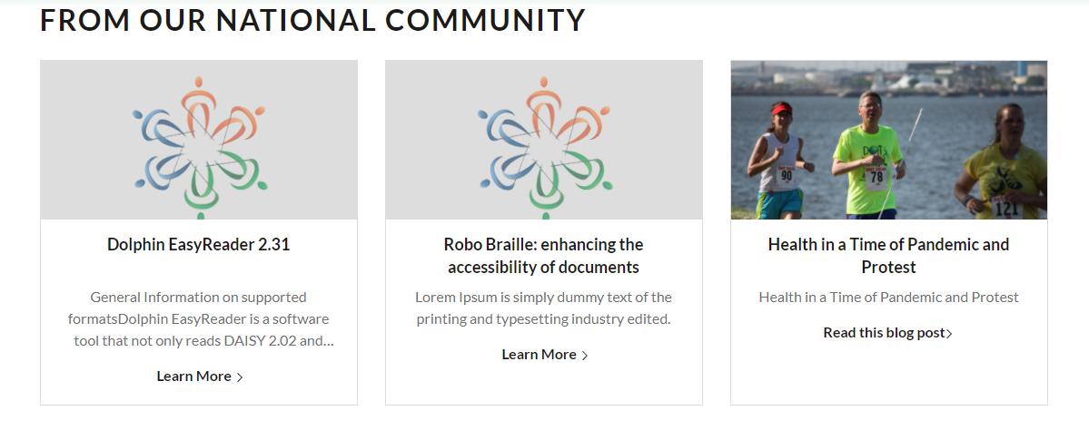
2 | For Design 2 the layout of the National Featured Content Section will displayed as shown in the next column. | 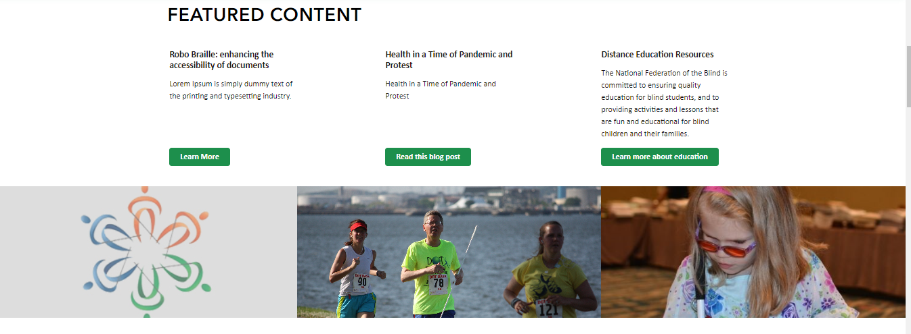

4.2. National Featured Content - Back End
The title of the National Featured Content is configurable for all the affiliates and all the templates.
Two step process need to be done to display that section.
# | Step
1 | To access National Featured Content section content editor will require to configure that section.  On the homepage edit option, content editor will be able to configure the option.  As per the reference screenshot the relevant option need to be choose by content editor.  They will require to configure fill in the title  Note : This title will not be displayed on the homepage, but that configuration is mentioned in the next step. | 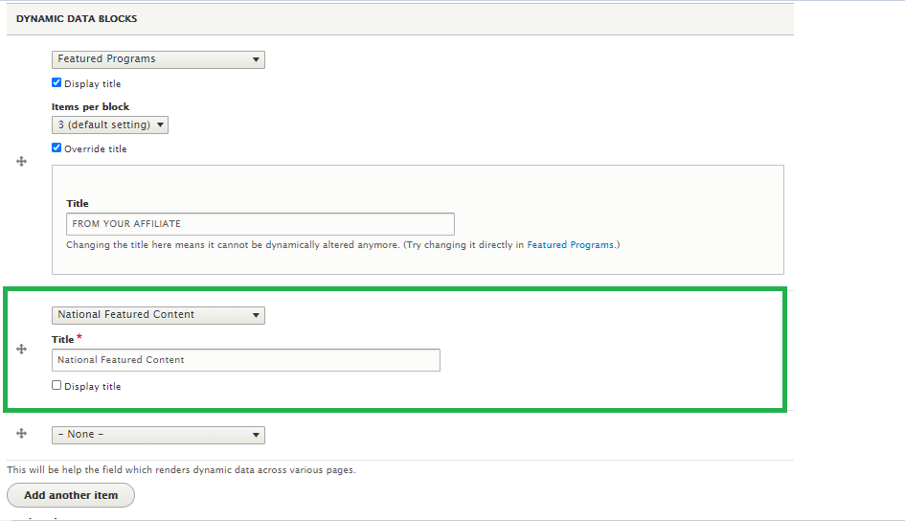
2 | To change the title or label of that section to be displayed on the Front End can be configured on from this URL : “website URL”/admin/config/nfbaff_national_content/config | 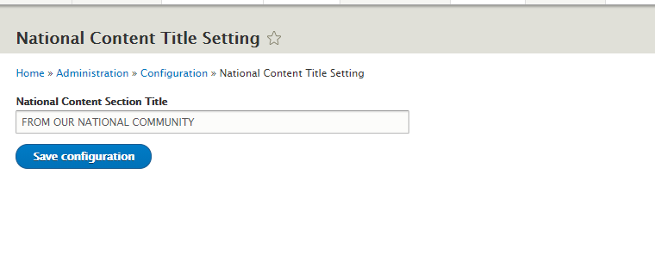

4. CiviCRM Sync
The forms like “Donation”, “Contact Us” on the affiliates sites are sync with CiviCRM on the respective sites. The functionality is achieved via custom module which is enabled by default in each of the affiliate site. The user information stored on the CiviCRM and are synced with national site’s CiviCRM. This functionality works internally the configuration like cron job will require to be done when configuring the server for production.

